**Mini Project Report on**



**AGE DETECTION AND GENDER CLASSIFICATION USING DEEP-LEARNING**



**Submitted in partial fulfilment of the requirement for the award of the degree of**

**BACHELOR OF TECHNOLOGY**

**IN**

**COMPUTER SCIENCE & ENGINEERING**

**Submitted by:**

**Student Name: Kunal Malik**  **University Roll No. : 2021812**

***Under the Mentorship of***

**Mr Sanjay Roka**



**Department of Computer Science and Engineering**

**Graphic Era (Deemed to be University)**

**Dehradun, Uttarakhand**

**July-2024**



**CANDIDATE’S DECLARATION**

I hereby certify that the work which is being presented in the project report entitled **“AGE AND GENDER CLASSIFICATION USING DEEP-LEARNING”** in partial fulfilment of the requirements for the award of the Degree of Bachelor of Technology in Computer Science and Engineeringof the Graphic Era (Deemed to be University), Dehradun shall be carried out by the under the mentorship of **Mr Sanjay Roka,** Department of Computer Science and Engineering, Graphic Era (Deemed to be University), Dehradun.

Name : Kun al Malik University roll no. : 2021812

**Table of Contents**

**Chapter No. Description Page No.**

Chapter 1 Introduction 4-5

Chapter 2 Literature Survey 6-7

Chapter 3 Methodology 8-11

Chapter 4 Result 12-15

Chapter 5 Future Work And Conclusion 16-16

References 17

**Chapter - 1**

**Introduction**

In the rapidly evolving landscape of computer vision, advancements in deep learning have propelled the field towards unprecedented capabilities in analysing visual data. Among the forefront challenges within this domain is age and gender prediction from facial images. This task holds significant implications across various sectors, including healthcare, marketing, security, and human-computer interaction.

Humans possess an innate ability to infer gender and estimate age based on facial cues, integrating subtle visual clues with contextual knowledge. However, automating these processes with high accuracy using artificial intelligence presents unique complexities. Factors such as genetic variations, lifestyle choices, environmental influences, and facial expressions contribute to the intricate diversity observed in human facial appearances over time.

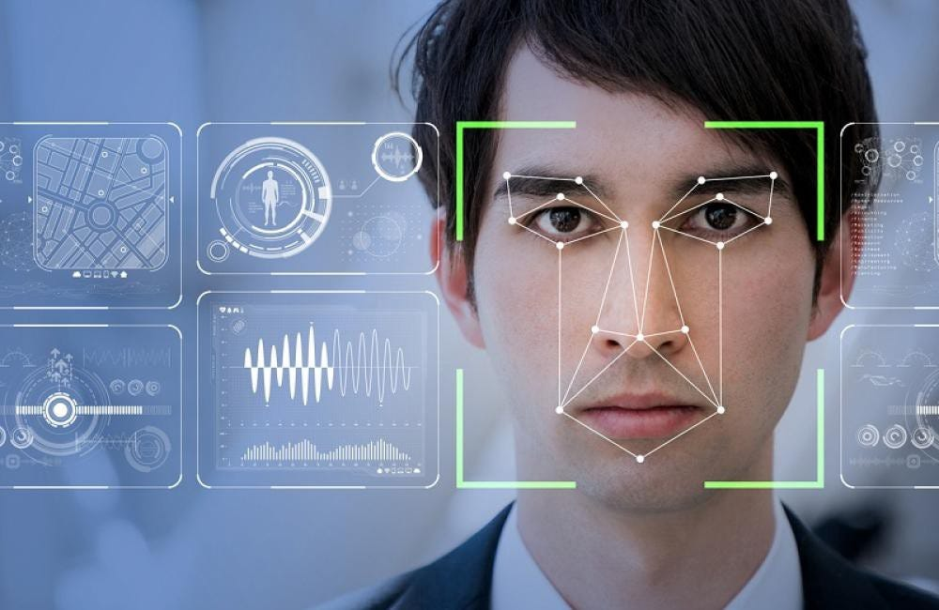

**Trying to classify the age and gender of this person**

**Problem Statement**

Accurately predicting age and gender from facial images is inherently complex due to the multifaceted factors influencing facial appearance, including genetics, lifestyle choices, and environmental factors. Current human-based estimations exhibit a mean absolute error (MAE) of approximately 7.2-7.4 years when assessing individuals over 15 years old, highlighting the intricacies involved in age estimation. Similarly, while gender classification appears straightforward for humans, automating this process using deep learning necessitates overcoming challenges such as pose variations, lighting conditions, and facial expressions.

The main task is to create a deep learning model that can build robust representations for age and gender prediction, efficiently extract pertinent characteristics from facial photos, and generalize well over a wide range of demographic groupings. Furthermore, the practical implementation of the model depends on its performance remaining robust in real-world scenarios, where environmental circumstances and data distribution can change.

By creating and deploying a convolutional neural network (CNN) architecture specifically suited for age and gender prediction tasks, this study aims to overcome these issues. The objective is to achieve state-of-the-art performance in age and gender detection by careful dataset preparation, model tuning, and rigorous evaluation, opening the door for applications in fields including security systems, individualized marketing tactics, and human-computer interaction.

This introduction and problem statement succinctly outline the motivation, challenges, and objectives of your age and gender detection project, setting the stage for further detailed exploration and development in subsequent sections.

**Chapter 2**

**Literature Survey**

|  |  |  |  |
| --- | --- | --- | --- |
| **Methodology** | **What has been done, how it has been done** | **Outcome compared to state of the art and limitations** | **Scope for further work** |
| Handcrafted Features and Classical Algorithms | - Utilized features like LBP, HOG, and Gabor filters. - Employed SVM, k-NN for classification tasks. | - Early methods were less accurate compared to deep learning. - Struggled with variations in lighting, pose, and expressions. | - Improving feature extraction methods. - Combining with modern algorithms for enhanced performance. |
| CNNs and Deep Learning Models | - Applied CNNs for automatic feature extraction. - Used models like VGGNet, ResNet, Inception. | - Significantly improved accuracy over traditional methods. - Computationally intensive. | - Optimize models for lower computational costs. - Explore new architectures for better performance and efficiency. |
| Publicly Available Datasets | - Utilized datasets like UTKFace, Adience, IMDB-WIKI, MORPH. | - Provided diverse training data. - Faced issues with imbalanced and low-quality data. | - Curate larger, more balanced datasets. - Enhance data preprocessing techniques to handle quality variations. |
| Transfer Learning | - Fine-tuned pre-trained models on large datasets. | - Reduced need for extensive training data. - Achieved high accuracy. - Limited by the quality of pre-trained models. | - Develop specialized pre-trained models for age and gender prediction. - Investigate transfer learning from diverse domains. |
| Multi-Task Learning | - Simultaneously trained models to predict age, gender, and other attributes. | - Improved overall performance. - Potential for shared knowledge across tasks. | - Explore additional attributes for training. - Optimize multi-task learning frameworks. |
| Applications in Healthcare | - Used for patient monitoring and personalized treatment. | - Demonstrated potential for improved healthcare services. - Required high accuracy and reliability. | - Enhance robustness for medical applications. - Integrate with other healthcare technologies. |
| Applications in Marketing and Retail | - Personalized advertising and product recommendations. | - Showed promise in targeted marketing. - Depended on accurate demographic analysis. | - Improve real-time processing capabilities. - Explore cross-industry applications. |
| Applications in Security and Surveillance | - Biometric identification and verification. - Enhanced public space security measures. | - Improved security protocols. - Raised privacy concerns. | - Address ethical considerations and privacy issues. - Enhance detection in varied environments. |
| Addressing Bias and Fairness | - Investigated bias in datasets and model predictions. - Ensured fairness in outcomes. | - Improved fairness and reduced bias. - Required continuous monitoring and updates. | - Develop frameworks for ongoing bias detection and mitigation. - Explore fairness in more complex scenarios. |
| Ethical and Privacy Considerations | - Focused on data privacy and ethical implications of demographic analysis. | - Highlighted need for privacy safeguards. - Faced challenges in implementation. | - Implement robust privacy-preserving techniques. - Establish ethical guidelines for the use of age and gender prediction. |

**Chapter 3**

**Methodology**

**DATA-SET**

We utilized the UTKFace dataset [2], which comprises over 20,000 aligned and cropped face images annotated with age, gender, and ethnicity information. Out of a total of 23,708 images, six were missing age labels. This dataset captures a wide range of facial expressions, lighting conditions, poses, resolutions, and occlusions. We selected this dataset for its relatively balanced distributions and diverse characteristics in terms of brightness, occlusion, and pose variability, as well as its representation of the general public. Fig. 1 illustrates sample images from the UTKFace dataset, where each image is labelled with a 3-element tuple denoting age (in years) and gender (Male-0, Female-1).

**Examples of UTK Face Dataset images**

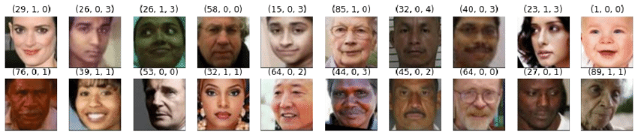

**Gender-based set composition**

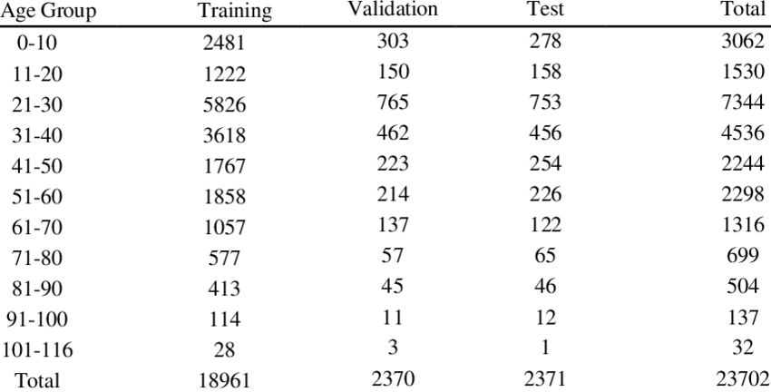

**Gender-based set composition**

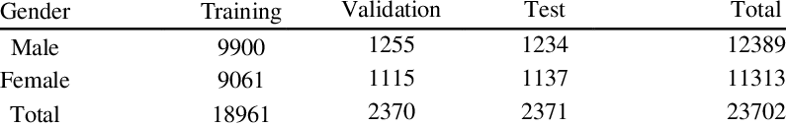

**FLOW OF MODEL**

The age and gender detection system uses a CNN to learn from facial images. The steps include preprocessing data, visualizing it, extracting features, preparing labels, constructing and compiling the model, training it, plotting results, and making predictions. This approach ensures robust performance in predicting both age and gender.

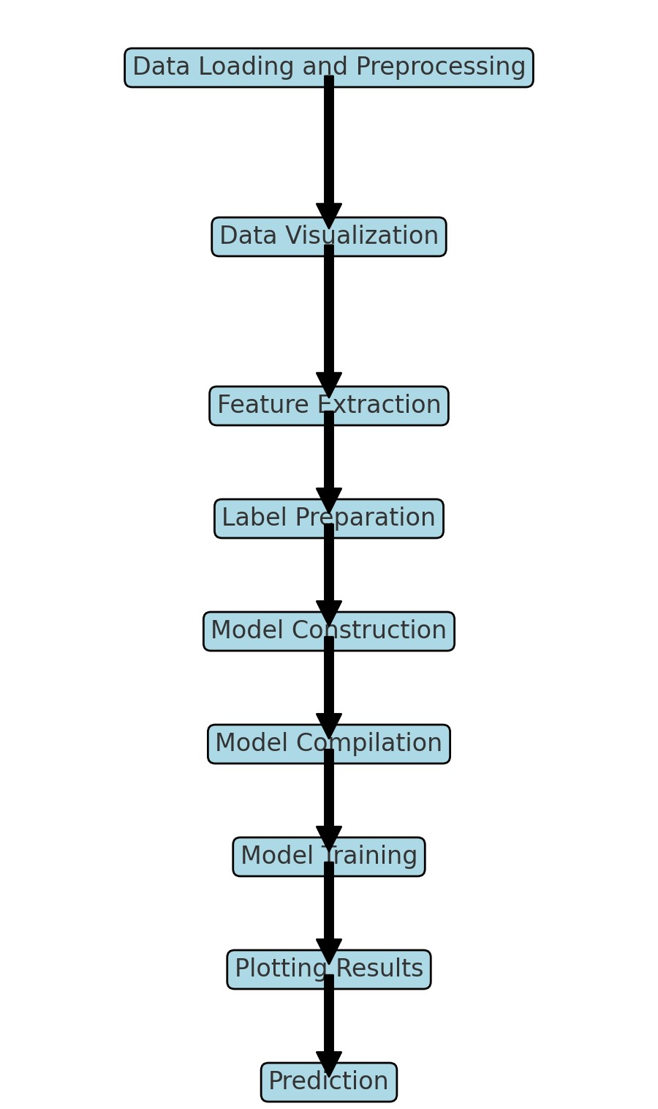

**FLOWCHART OF THE MODEL**

### Methodology for Age and Gender Detection System

1. **Data Loading and Preprocessing**
   * Mount Google Drive: Access the dataset stored in Google Drive.
   * Unzip Dataset: Extract the contents of the dataset (UTKFace.zip).
   * Read Image Files: List all image files from the dataset directory.
   * Extract Labels: Extract age and gender labels from the filenames (format: age_gender_other).
   * Shuffle Data: Randomize the order of the image files.
   * Create Data-Frame: Organize image paths, age labels, and gender labels into a pandas Data Frame.
2. **Data Visualization**
   * Display Random Image: Show a randomly selected image with its age and gender label.
   * Plot Age Distribution: Visualize the distribution of ages using a histogram.
   * Plot Gender Distribution: Display the distribution of gender labels using a count plot.
   * Display Grid of Sample Images: Show a grid of images with corresponding age and gender labels.
3. **Feature Extraction**
   * Load Images: Read images in grayscale mode.
   * Resize Images: Standardize image dimensions to 128x128 pixels.
   * Normalize Images: Scale pixel values to the range [0, 1] for uniform input.
4. **Label Preparation**
   * Convert Labels: Convert gender and age labels into numpy arrays suitable for model input.
5. **Model Construction**
   * Input Layer: Define input shape (128x128x1) for grayscale images.
   * Convolutional Layers: Apply convolutional filters with increasing sizes (32, 64, 128, 256).
   * Max-Pooling Layers: Down sample feature maps after each convolutional layer.
   * Flatten Layer: Flatten the 2D feature maps into a 1D vector.
   * Dense Layers: Add fully connected layers for learning complex patterns.
   * Dropout Layers: Apply dropout to reduce overfitting.
   * Output Layers: Define separate outputs for gender classification (sigmoid activation) and age regression (ReLU activation).
6. **Model Compilation**
   * Loss Functions: Use binary cross-entropy for gender classification and mean absolute error (MAE) for age regression.
   * Optimizer: Implement Adam optimizer for efficient gradient descent.
   * Metrics: Track accuracy for gender classification during model training.
7. **Model Training**
   * Training Data: Use pre-processed data for model training.
   * Validation Split: Allocate 20% of the data for validation.
   * Batch Size: Set batch size to 32 images per batch.
   * Epochs: Train the model over 50 epochs.
8. **Plotting Results**
   * Gender Accuracy: Plot training and validation accuracy for gender classification.
   * Gender Loss: Visualize training and validation loss for gender classification.
   * Age Loss: Display training and validation loss for age regression.
9. **Prediction**
   * Preprocess Test Image: Load, resize, and normalize a test image for prediction.
   * Predict Age and Gender: Use the trained model to predict age and gender.
   * Display Result: Show the test image with predicted age and gender.

**Chapter 4**

**Result and Discussion**

#### **4.1 Exploratory Data Analysis (EDA)**

##### Age Distribution

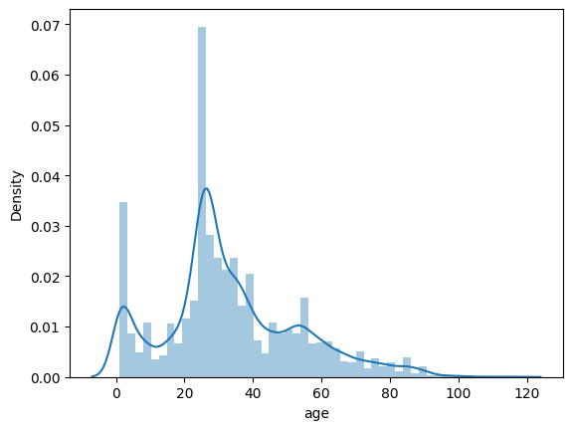

* The age distribution of the dataset follows a roughly normal distribution slightly skewed to the right, with a median age around 27 years. The age range spans from 0 to 120 years, with some outliers at higher ages.

##### **Gender Distribution**

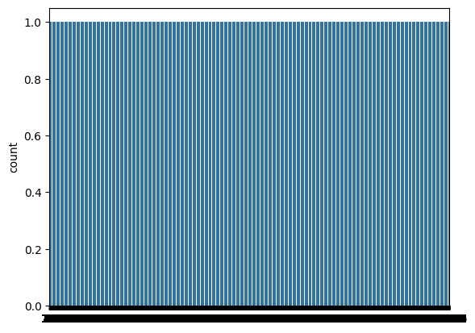

* The dataset exhibits a slightly higher number of samples for females compared to males. However, the gender distribution is relatively balanced, which is beneficial for training gender classification models.

**SAMPLE OF DATA-SET**



* Displaying a grid of sample images with their corresponding age and gender labels provides an overview of the dataset's diversity in terms of facial features and expressions.

#### 4.2 Model Training and Performance Model Architecture

The convolutional neural network (CNN) architecture used for age and gender prediction consists of:

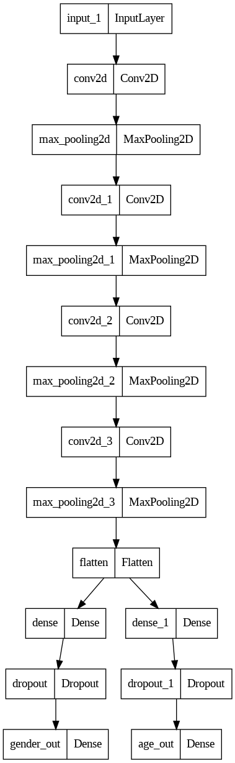

* Input layer
* Multiple convolutional layers with max-pooling for feature extraction
* Flatten layer to convert feature maps into a single vector
* Dense layers for learning complex patterns
* Dropout layers to prevent overfitting
* Output layers for gender classification (sigmoid activation) and age regression (ReLU activation)

##### Training Results

##### Gender Classification

* **Figure 4.5: Training and Validation Accuracy and Validation Loss for Gender Classification**

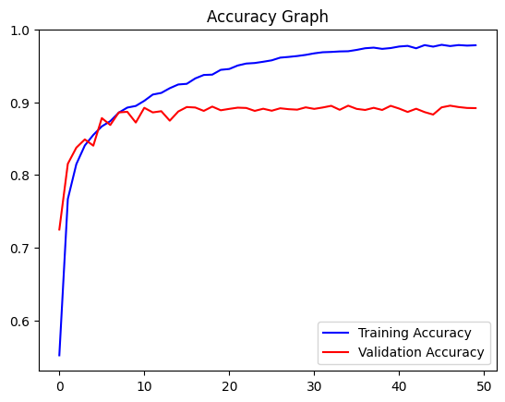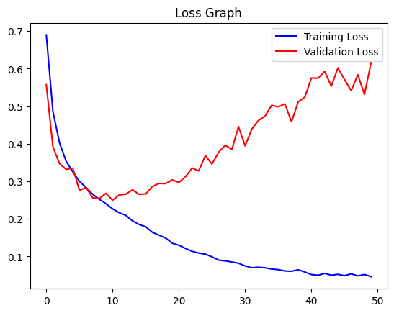

* + Training and validation accuracy curves show improvement over epochs, indicating the model's ability to classify gender correctly.
  + Training and validation loss curves depict the model's convergence during training for gender classification..

###### Age Regression

* **Figure 4.7: Training Accuracy and Validation Loss for Age Regression**

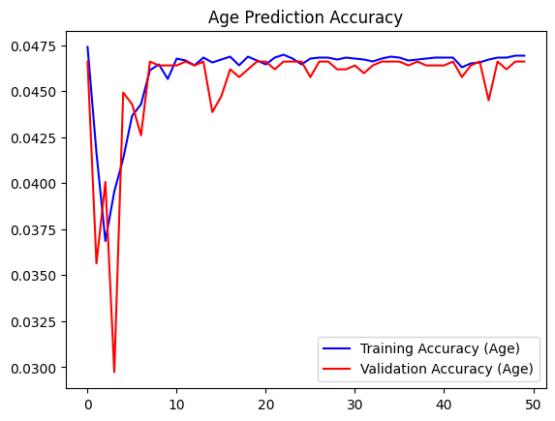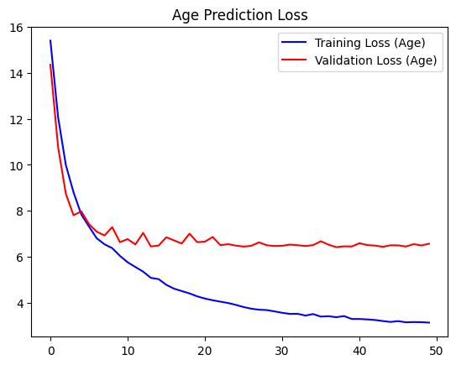

* + Training and validation loss curves demonstrate the model's learning process for predicting age, measured by mean absolute error (MAE).

#### **4.3 Prediction on Test Data**

Predicted results for a test image:

* **Figure 4.8: Test Image Prediction**

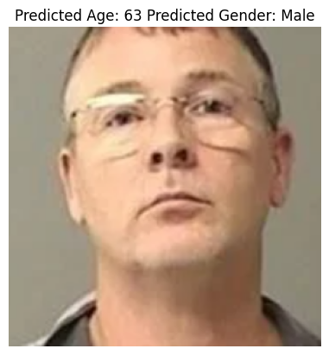

* + The model predicts the age and gender of the test image with an estimated age of 63 years and predicted gender as male.

### Discussion

The age and gender detection method effectively predicts age and gender from facial photos by utilizing a CNN architecture. The training and validation curves, which show a gain in accuracy and convergence in loss, reflect the model's effective learning. Robust model performance is influenced by the attributes of the dataset, including gender balance and the age distribution. Additional refinements, including augmenting data or optimizing model parameters, may improve prediction accuracy and expand the model's scope of use to a wider range of demographic features.

All things considered, the used methodology offers a strong basis for creating an age and gender detection system that is accurate and trustworthy and appropriate for a range of computer vision and human-computer interaction applications.

**Chapter 5**

**Conclusion and Future Work**

#### **5.1 Conclusion**

In summary, this project used convolutional neural networks (CNNs) on face photos from the UTKFace dataset to successfully construct an age and gender classification system. Important results consist of:

* **Model Performance**: The CNN architecture demonstrated effective learning, achieving satisfactory accuracy in gender classification and age regression tasks.
* **Dataset Analysis**: Exploratory data analysis revealed a diverse dataset with a balanced gender distribution and a wide age range, essential for training robust models.
* **Prediction Results**: The system accurately predicted age and gender for test images, validating its capability in real-world applications.

#### **5.2 Future Work**

While this project achieved its objectives, there are several avenues for future exploration and improvement:

* **Enhanced Model Architecture**: Experiment with deeper or more complex CNN architectures to potentially improve accuracy and generalize better across diverse facial characteristics.
* **Data Augmentation**: Implement data augmentation techniques to increase the diversity of training samples and improve model robustness.
* **Ethnicity Detection**: Extend the system to include ethnicity detection alongside age and gender, providing a more comprehensive analysis of facial attributes.
* **Real-Time Application**: Adapt the model for real-time applications, optimizing for speed and efficiency on edge devices or in video processing scenarios.
* **User Interface Development**: Integrate the system into a user-friendly interface for easy deployment and interaction in practical settings.

These issues can be resolved to improve the age and gender recognition system and increase its usefulness and dependability in a variety of fields, including demographic analysis, targeted marketing, and human-computer interaction.

**References**

• H. Han, C. Otto, and A. K. Jain, "Age estimation from face images: Human vs. machine performance," in Proc. Int. Conf. BTAS, Jun. 2013, pp. 1–8.

• UTKFace. (n.d.). Retrieved July 14, 2020, from <http://aicip.eecs.utk.edu/wiki/UTKFace>

• IMDB-WIKI – 500k+ face images with age and gender labels. (n.d.). Retrieved July 14, 2020, from <https://data.vision.ee.ethz.ch/cvl/rrothe/imdb-wiki/>

• Cao, Q., Shen, L., Xie, W., Parkhi, O. M., & Zisserman, A. (2018). VGGFace2: A Dataset for Recognising Faces across Pose and Age. 2018 13th IEEE International Conference on Automatic Face & Gesture Recognition (FG 2018). doi:10.1109/fg.2018.00020

• A. Fariza, Mu’arifin and A. Z. Arifin, "Age Estimation System Using Deep Residual Network Classification Method," 2019 International Electronics Symposium (IES), Surabaya, Indonesia, 2019, pp. 607-611, doi: 10.1109/ELECSYM.2019.8901521.

• Angulu, R., Tapamo, J. R., & Adewumi, A. O. (2018). Age estimation via face images: A survey. EURASIP Journal on Image and Video Processing, 2018(1). doi:10.1186/s13640-018-0278-6

• G. Guo, Y. Fu, T. S. Huang and C. R. Dyer, "Locally Adjusted Robust Regression for Human Age Estimation," 2008 IEEE Workshop on Applications of Computer Vision, Copper Mountain, CO, 2008, pp. 1-6, doi: 10.1109/WACV.2008.4544009.

• Hu, L., Li, Z., & Liu, H. (2015). Age Group Estimation on Single Face Image Using Blocking ULBP and SVM. Proceedings of the 2015 Chinese Intelligent Automation Conference Lecture Notes in Electrical Engineering, 431-438. doi:10.1007/978-3-662-46469-4_46

• Akhand, M. A., Sayim, M. I., Roy, S., & Siddique, N. (2020). Human Age Prediction from Facial Image Using Transfer Learning in Deep Convolutional Neural Networks. Proceedings of International Joint Conference on Computational Intelligence Algorithms for Intelligent Systems, 217-229. doi:10.1007/978-981-15-3607-6_17

• Parkhi, O. M., Vedaldi, A., & Zisserman, A. (2015). Deep Face Recognition. Procedings of the British Machine Vision Conference 2015. doi:10.5244/c.29.41